Lauderdale Profiles

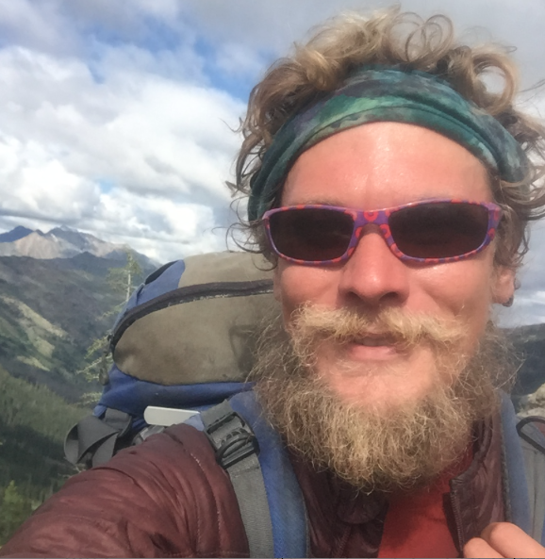
Jason Brewster RHS ‘03
Equine Director/Program Specialist Camp Henry
Bachelor of Science Psychology, Masters Clinical Psychology
Mississippi State University, Palo Alto University

Q: How did you select your college major, certification program, or career path?
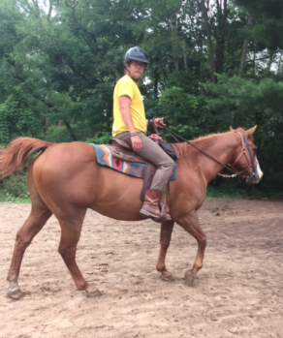
A: Most of it fell into place. I originally went to MSU to study Aerospace engineering for the Air Force but after my ROTC scholarship was taken away due to a medical condition I was diagnosed with a couple of weeks prior to college, my heart was no longer into pursuing that. I took a semester to take electives and became intrigued with Psychology and studied that for the remainder of my time. My current career path came about after my heart wasn't in providing therapy for kids anymore as it weighed on me, and a dear friend happened to call me at the right time and offered me a job with a camp in Michigan.

Q: What was the biggest influence in your selection of career path?
A: I enjoy connecting with people. Learning and practicing psychology is one of the best ways to do that but it can weigh heavy on you as you do have to connect with people often times in their worst mental states. I still connect with lots of people often, and my ability to make those connections as well as know a lot about behavior and how to change it helps me connect with the people we serve and to train the horses I work with.

Q: If you could go back to high school and select any elective course to take that would have better prepared you for college/career, what would it be?
A: FHA and Boy Scouts would be something I would invest time in.

Q: What is your favorite aspect of your job?
A: Despite the hard work in taking care of a herd of animals, I love getting to utilize them with the kids I work with. Also, my job allows me creative freedoms to do, try, and tweek a variety of ideas that may come to me. I work with people I am lucky enough to call my friends, and I get to have a lot of fun. When we have campers or groups here, I am usually the biggest kid despite my age.

Q :How do you/your company make a positive impact on society/our community?
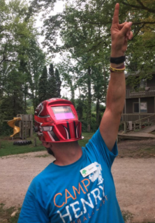
A: We provide a number of services that include: team building, developing communication skills, pushing you outside of your comfort zone, problem solving abilities, outdoor education, survival skills, etc. in a place where we encourage you to be yourself in the purest form.

Q: What’s the most interesting thing you have been able to do in your professional career?
A: I haven't had a career in the traditional sense, but help kids develop and practice skills that will help them be a positive influence on the world

Q: What makes you get up each morning excited about your profession?
A: My alarm haha.... no I get up because I am serving kids. I want to see the smiles on their faces, be there for when they accomplish a goal that at first seemed impossible, help that light bulb come on when they finally understand something, and just grow overall.

Q: What advice would you share with K-12 students who are considering your profession?
A: Make connections with people in general. You never know how many people your friends know. Study people, behavior, personalities, and get experience working with them every chance you can. Never stop growing as an individual and be open to trying new things. If you would have told me 10 years ago that I would be working with kids and in charge of a herd of horses I would have said you were crazy.

Q: What were some of the jobs you held as a young person (summer jobs, part time work, etc.), before you were on your career path? Did they play any part in your future occupation?
A: Special Olympics Volunteer, the Mission work I did, construction (really developed a good work ethic in me), and just my intention to know people and make a relationship with them.... everything I've done has led me to my current path in one form or another. It has led me to step out of my comfort zone, work with kids, continue my education in an informal way, hike across the country, take over a job that I am now learning on the fly (how to take care of and train horses). For me I've been searching for a career that I love, and right now this is what I am enjoying doing. However, I will say that when I feel my current career is no longer providing me that personal challenge and growth that I need, I will move on to something else. It’s why I've done a lot and am a sort of a jack of all trades guy.

